JENKINS – CHALLENGES

- Opened Jenkins → New Item
- Entered job name: hiring_app_declarative
- Selected Pipeline
- Clicked OK

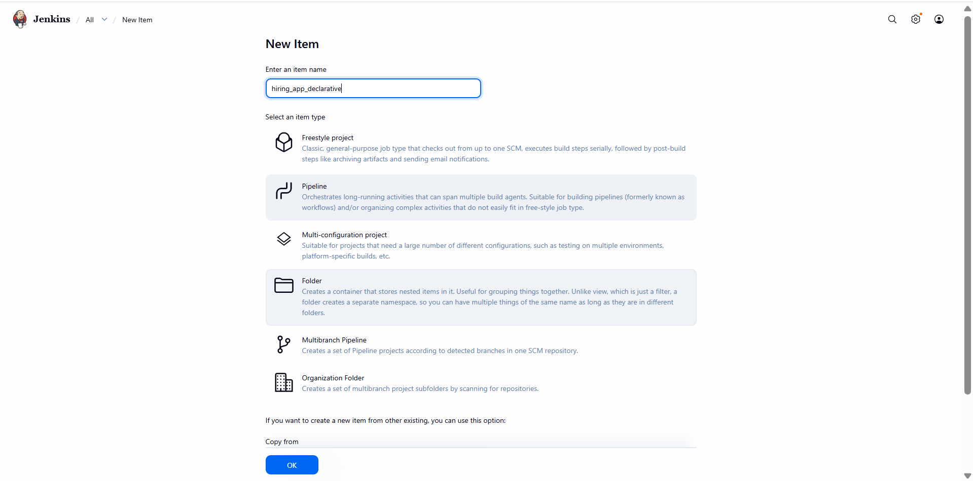

- Opened Configure → Pipeline
- Defined:
  - agent any
  - timestamps() option
- Added environment variables:
  - Maven home & PATH
  - Sonar project key/name
  - Nexus URL, repository, version, protocol
  - Tomcat URL
  - Slack channel
- Saved configuration

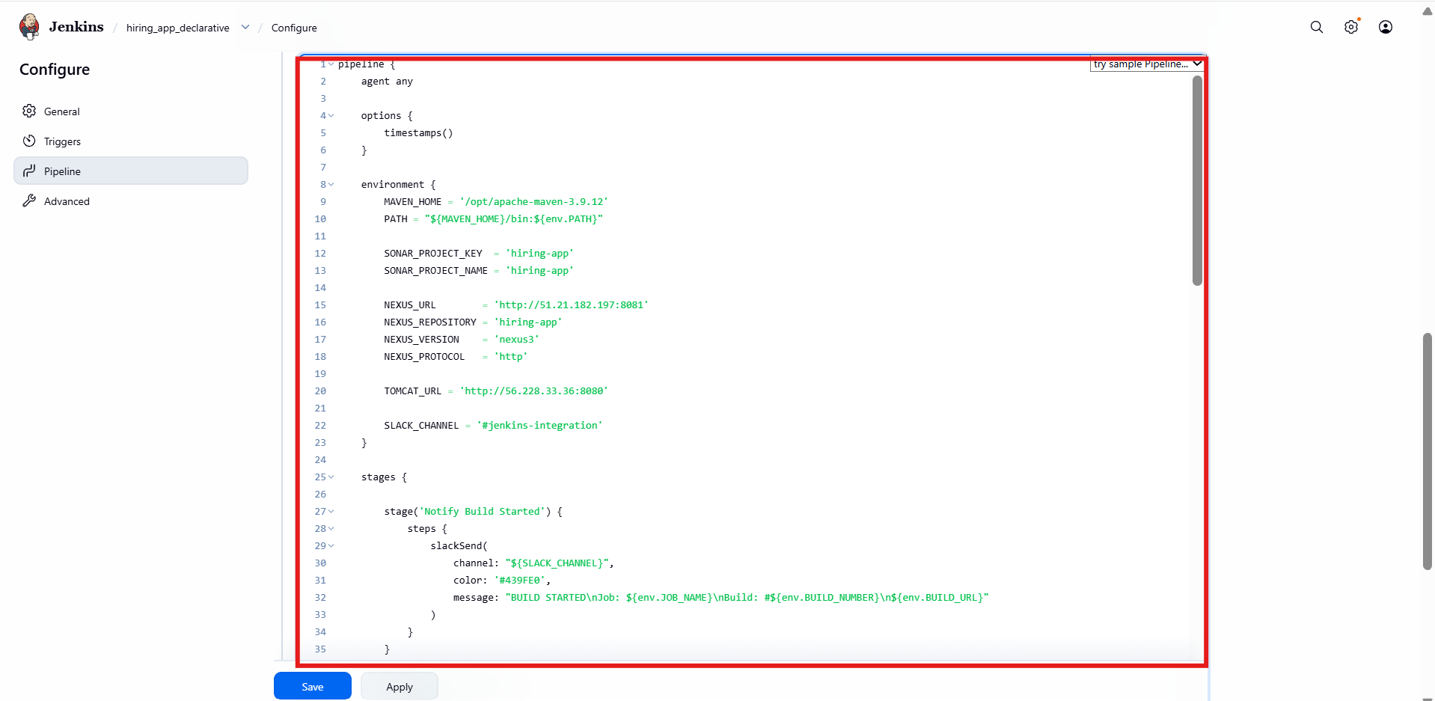

- Added Checkout Code stage (GitHub repo + branch)
- Added SonarQube Analysis stage using withSonarQubeEnv
- Added Maven Build stage:
  - mvn clean package -DskipTests
- Ensured stages order is correct

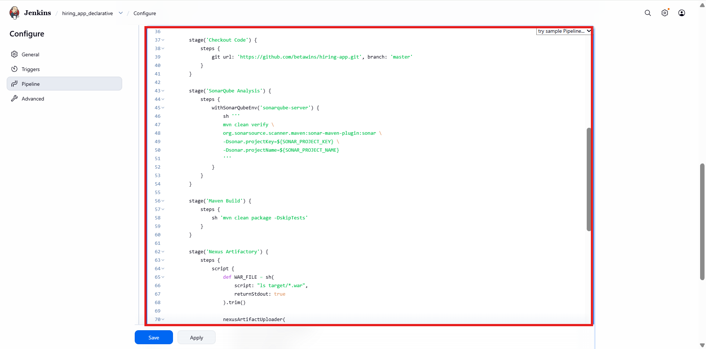

- Added Nexus Artifactory stage
- Captured WAR from target/*.war
- Configured:
  - Nexus protocol, URL, repository
  - Credentials ID
  - Group ID, artifact ID, version (SNAPSHOT)
- Enabled artifact upload

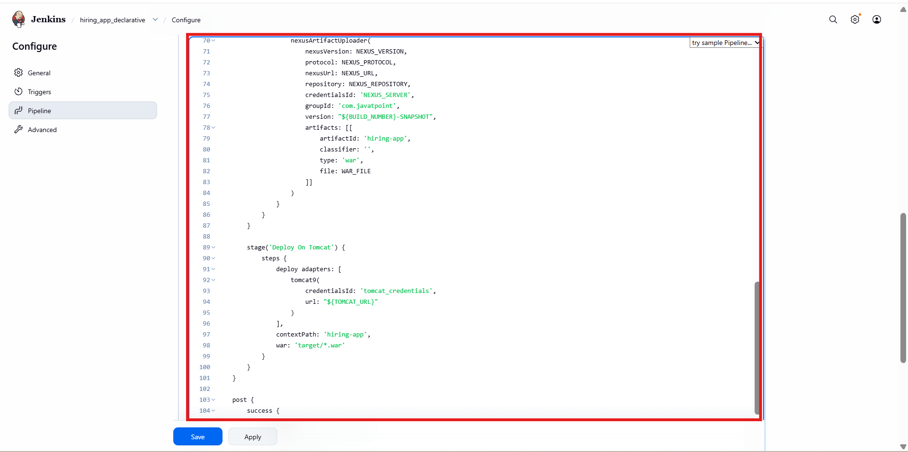
Added Deploy on Tomcat stage
Configured:
- Tomcat credentials
- ${TOMCAT_URL}
- Context path
- WAR file path
Added post section:
- Slack notification on success
- Slack notification on failure

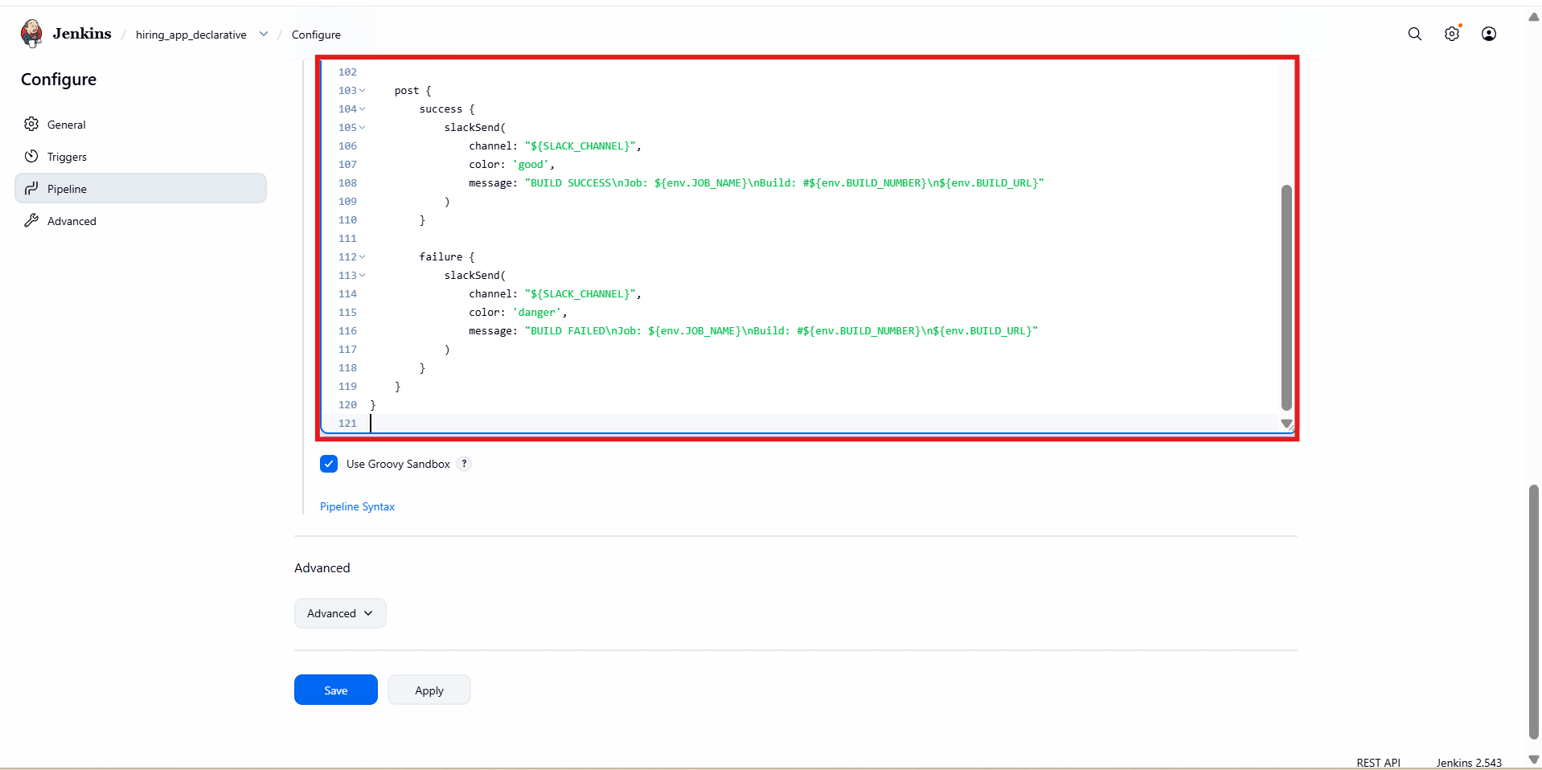
- Pipeline started successfully
- Multiple stages failed (red)
- Indicates configuration issues (branch, repo, credentials)

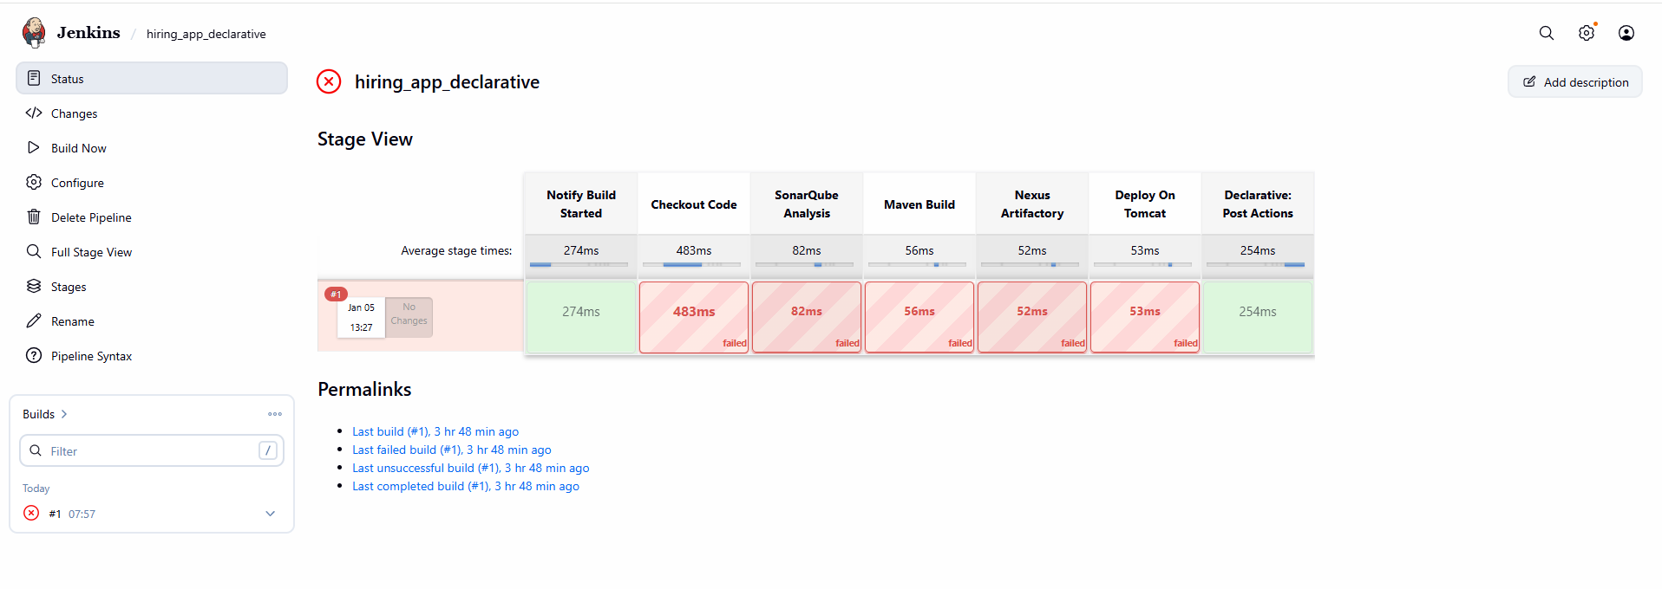

- Updated Checkout Code stage
- Corrected branch name (e.g., main)
- Saved pipeline

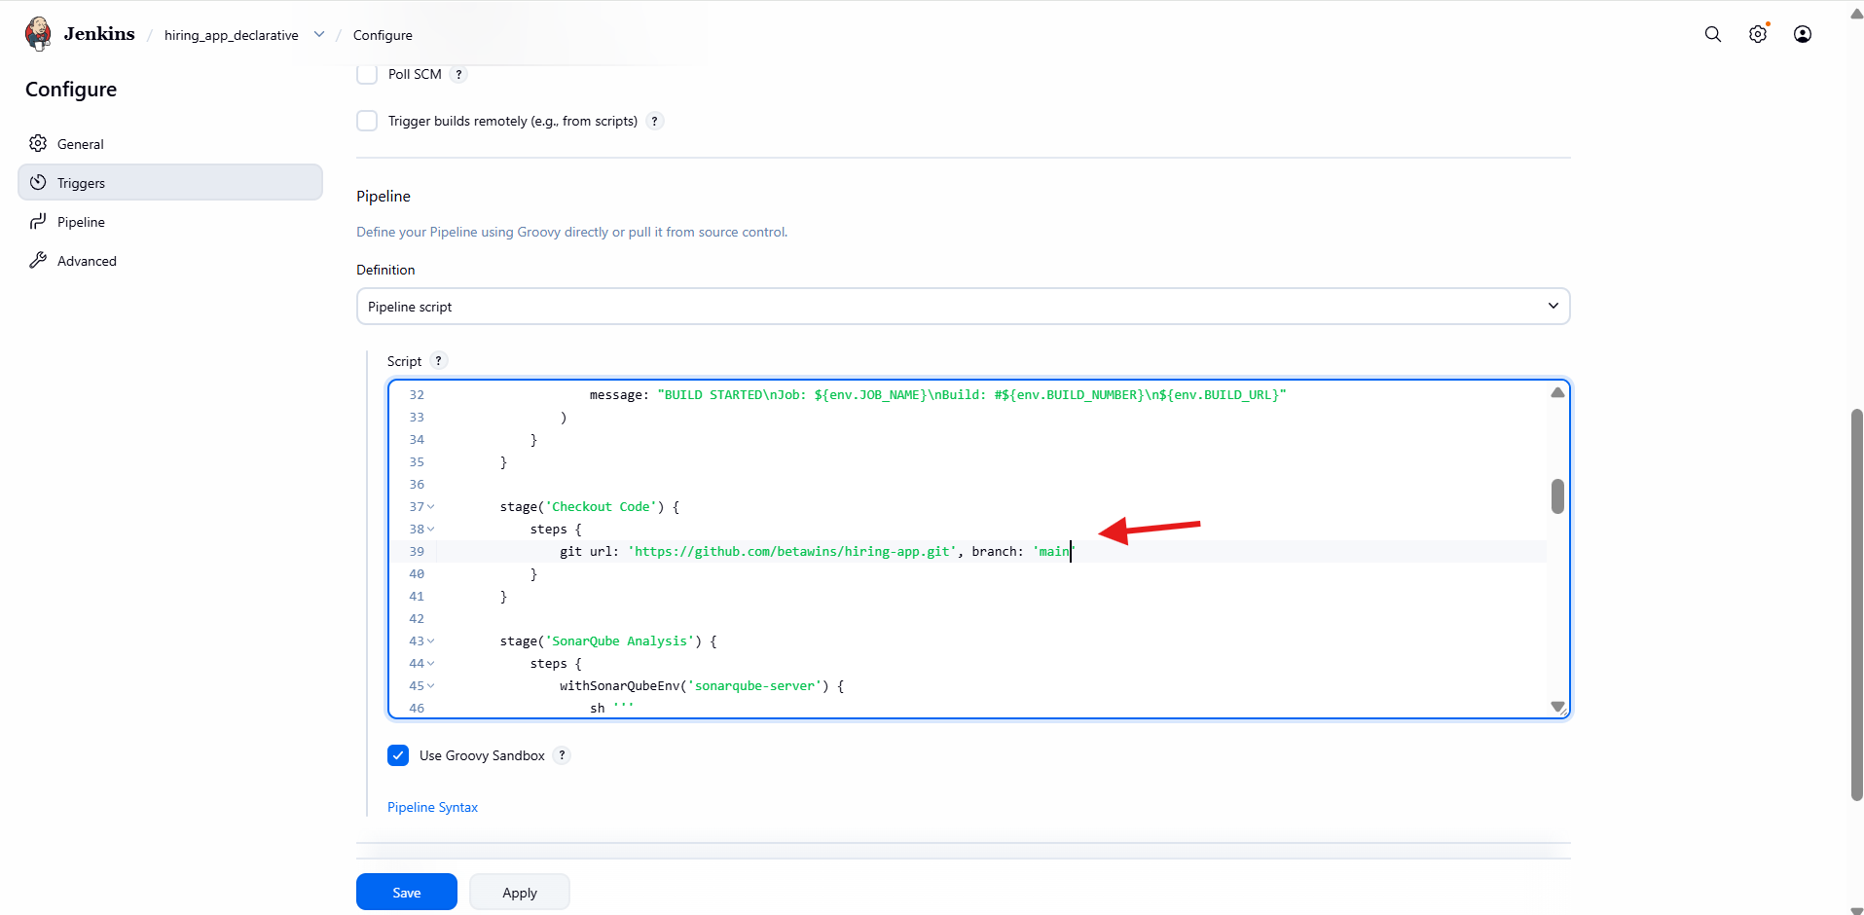

- Checkout succeeded
- Some stages still failing (Nexus/Tomcat)
- SonarQube stage passes

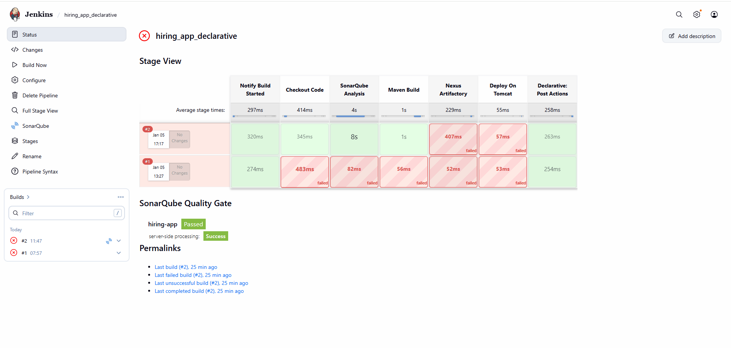

- Remove http in front of nexus url
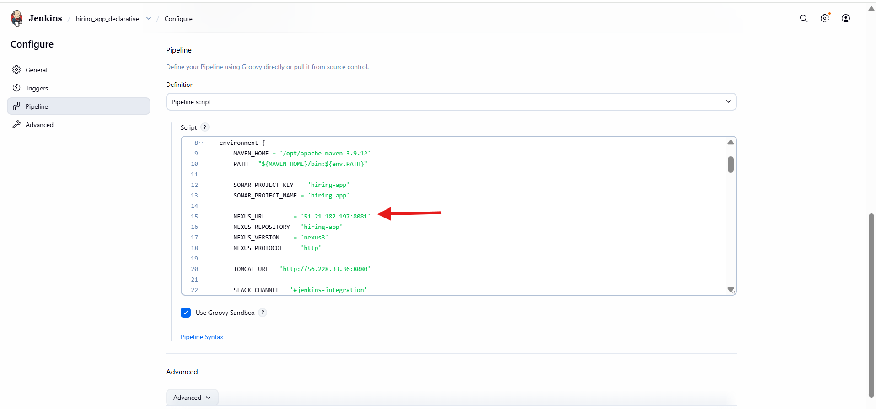
- Logged into Sonatype Nexus Repository
- Created/verified maven2 (hosted) snapshot repo
- Set:
  - Version policy: Snapshot
  - Layout: Permissive
  - Deployment policy: Allow redeploy

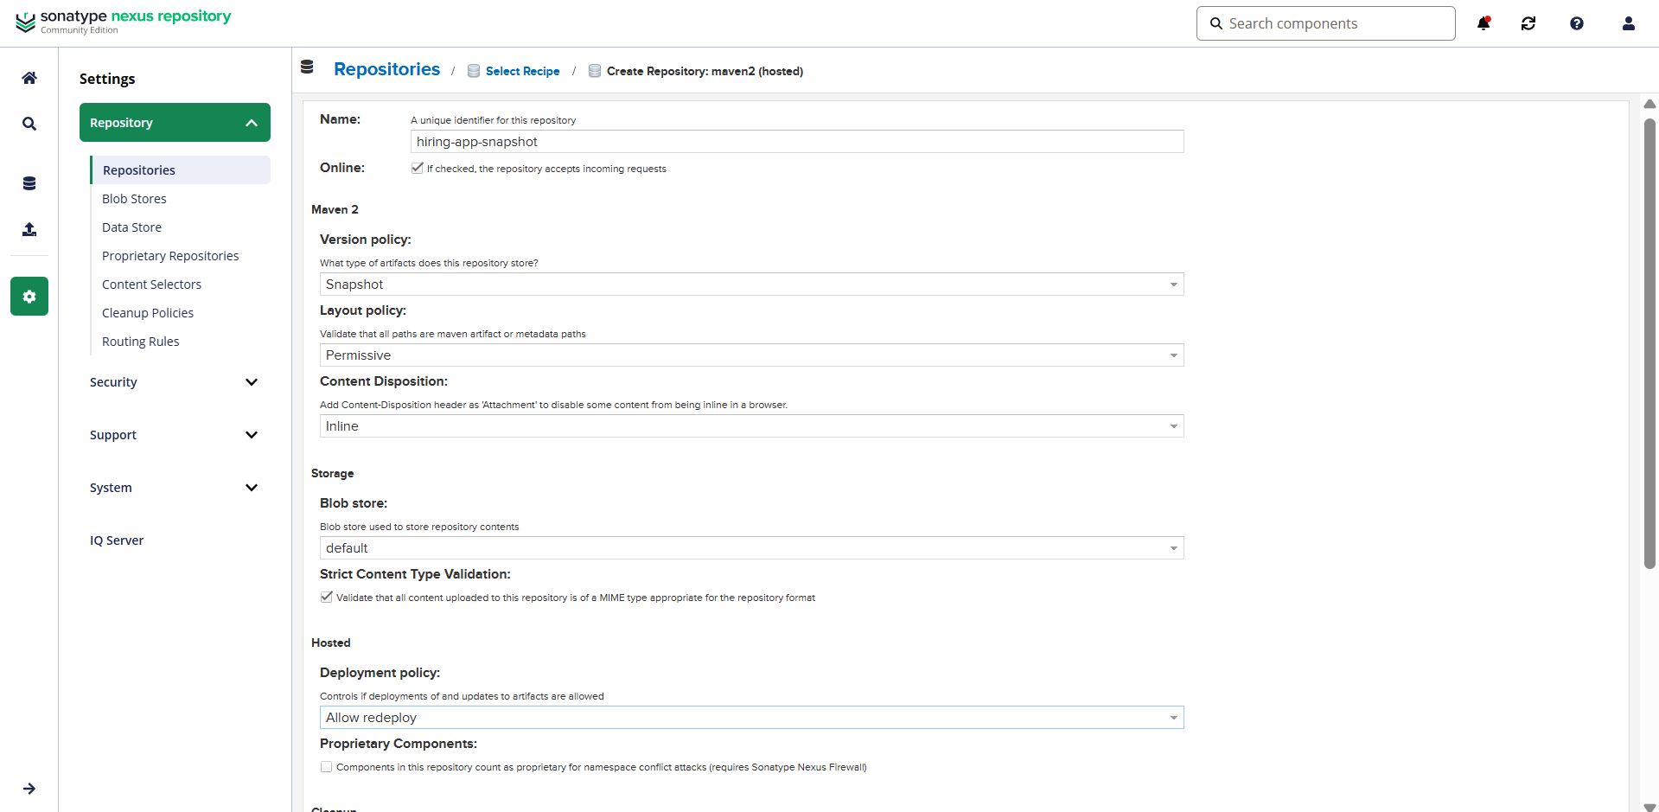

Upload to Nexus (SNAPSHOT) stage succeeds
Artifact visible in Nexus
Confirms Nexus credentials and repo settings are correct

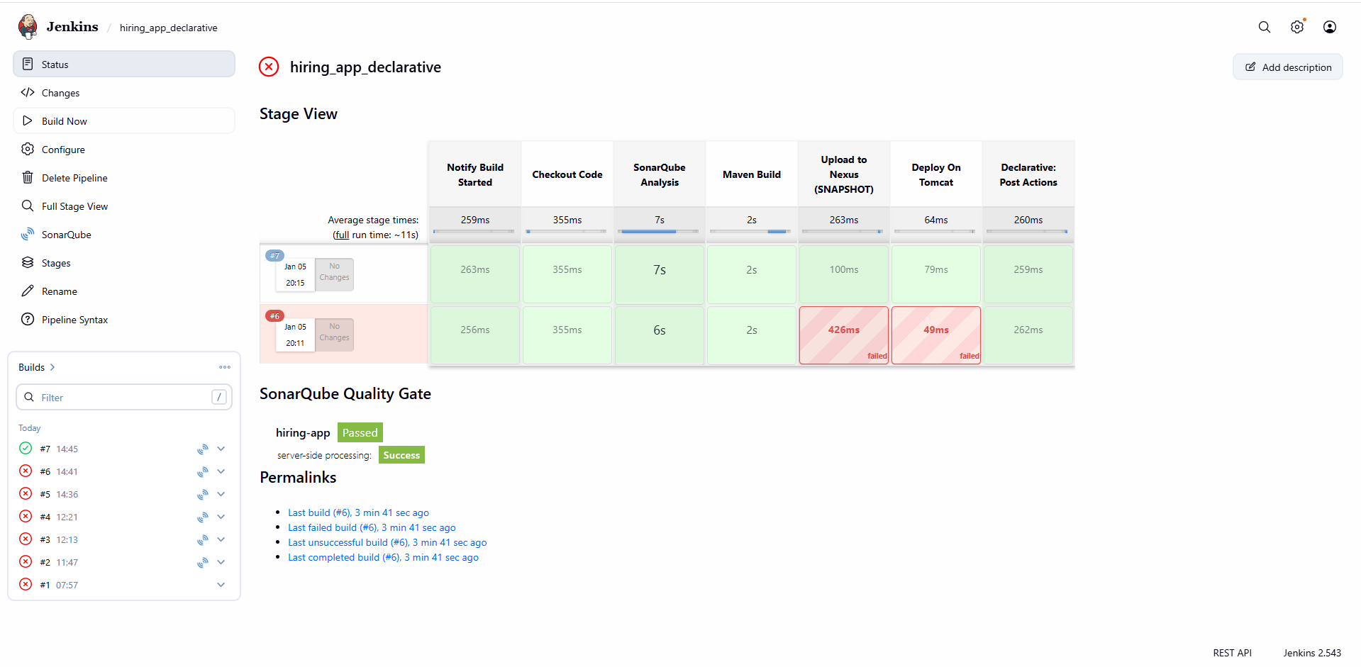

- Create one Scripted pipeline job

- Opened Jenkins → New Item
- Entered job name: hiring_app_scripted
- Selected Pipeline
- Clicked OK

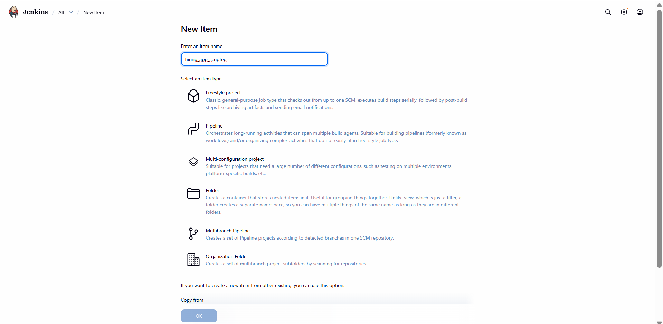

- Opened Configure → Pipeline
- Used Scripted Pipeline (node {})
- Defined environment variables:
  - Maven home and PATH
  - Sonar project key and name
  - Nexus URL, repository, protocol
  - Group ID, artifact ID, version
  - Tomcat URL
  - Slack channel
- Enabled timestamps
- Added Notify Build Started Slack stage

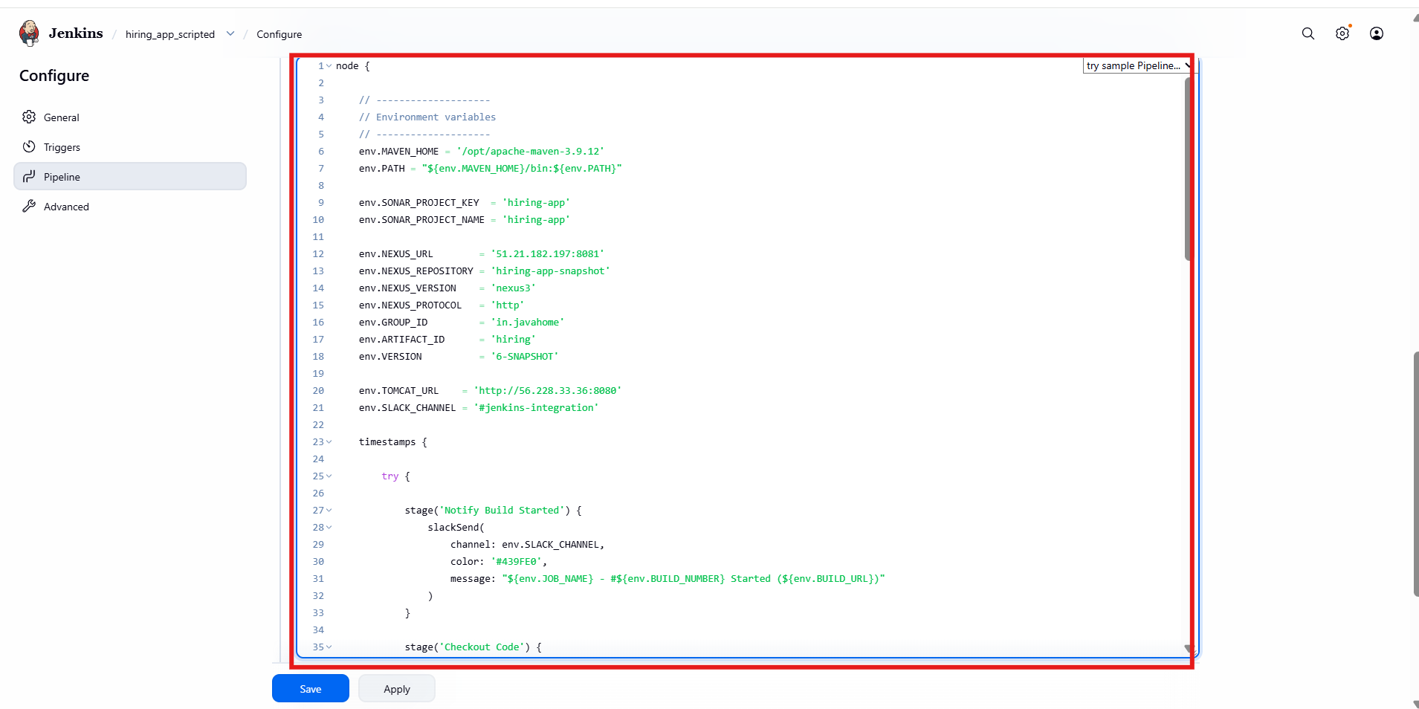

- Added Checkout Code stage
  - GitHub repository
  - Branch: main
- Added SonarQube Analysis stage
  - Used withSonarQubeEnv
  - Maven Sonar scan command
- Added Maven Build stage
  - mvn clean package -DskipTests
  - WAR generated in target/
- Added Upload to Nexus (SNAPSHOT) stage
- Used nexusArtifactUploader
- Configured:
  - Nexus URL and protocol
  - Snapshot repository
  - Credentials ID
  - Group ID, artifact ID
  - Version: SNAPSHOT
  - WAR file path

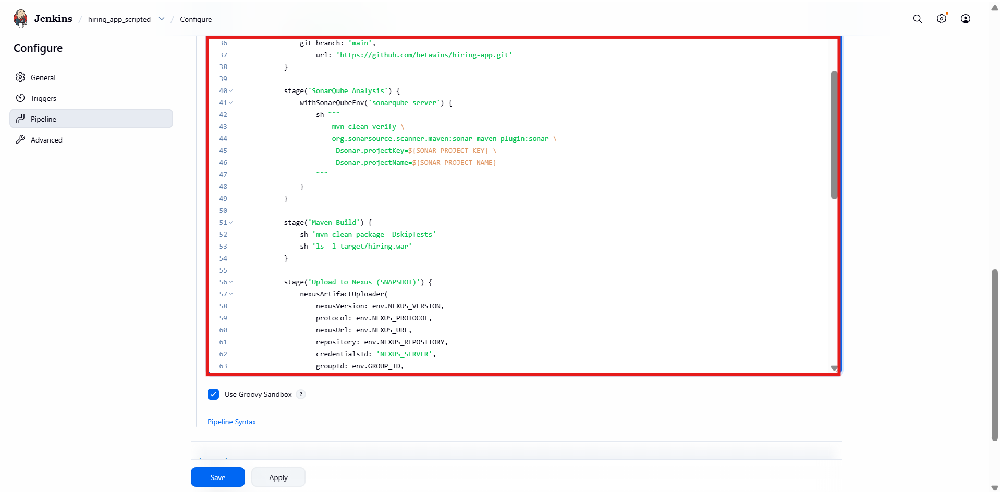

- Added Deploy on Tomcat stage
- Used Tomcat deploy adapter
- Configured:
  - Tomcat credentials
  - Tomcat URL
  - Context path: hiring
  - WAR file: target/hiring.war
- Added Notify Success stage
- Slack message includes:
  - Job name
  - Build number
  - Build URL
- Message color set to green

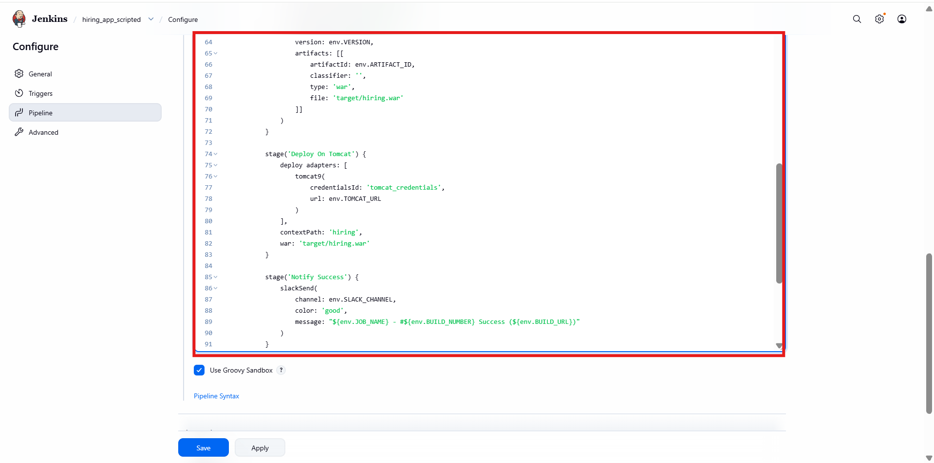

Wrapped pipeline inside try–catch
Added Notify Failure Slack stage
Message color set to danger
Re-throws error to fail the build properly

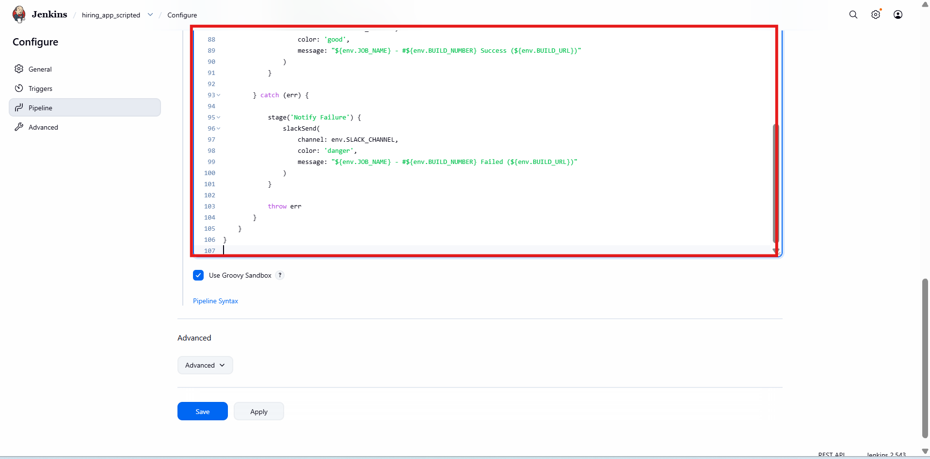

Pipeline stages executed successfully:
- Notify Build Started
- Checkout Code
- SonarQube Analysis
- Maven Build
- Upload to Nexus (SNAPSHOT)
- Deploy on Tomcat
- Notify Success
All stages shown in green

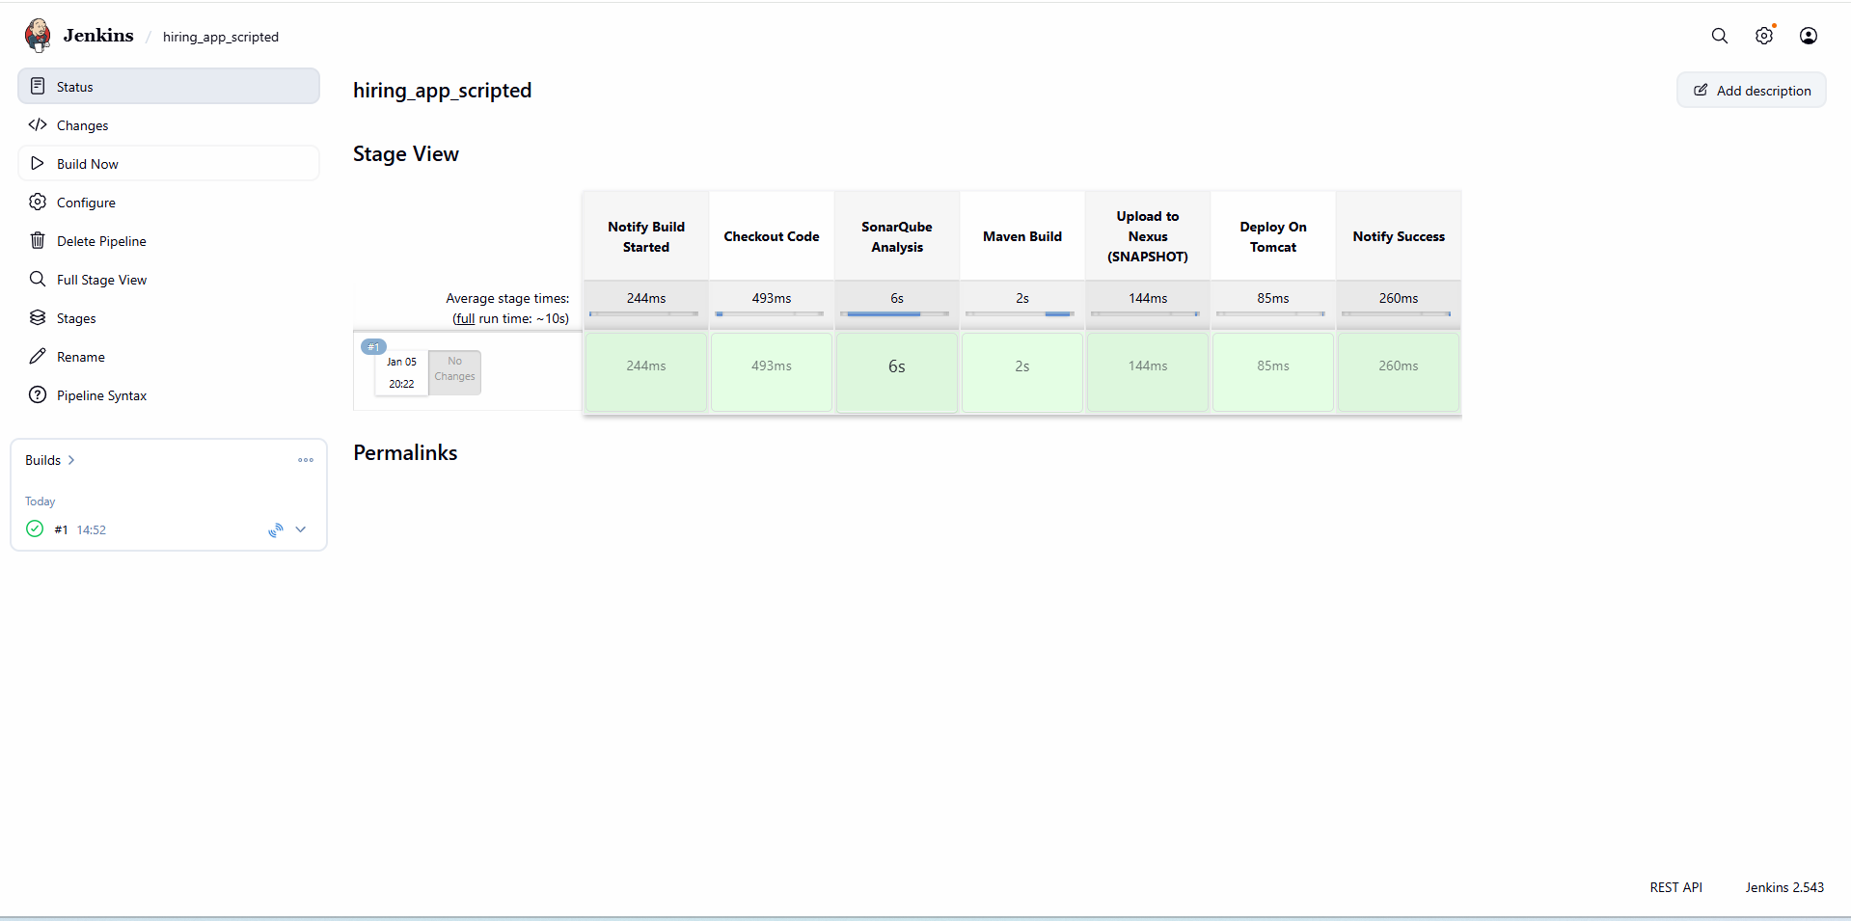

- Create one multi stage pipeline job
- Opened Jenkins → New Item
- Entered job name: multistage_pipeline
- Selected Pipeline
- Clicked OK

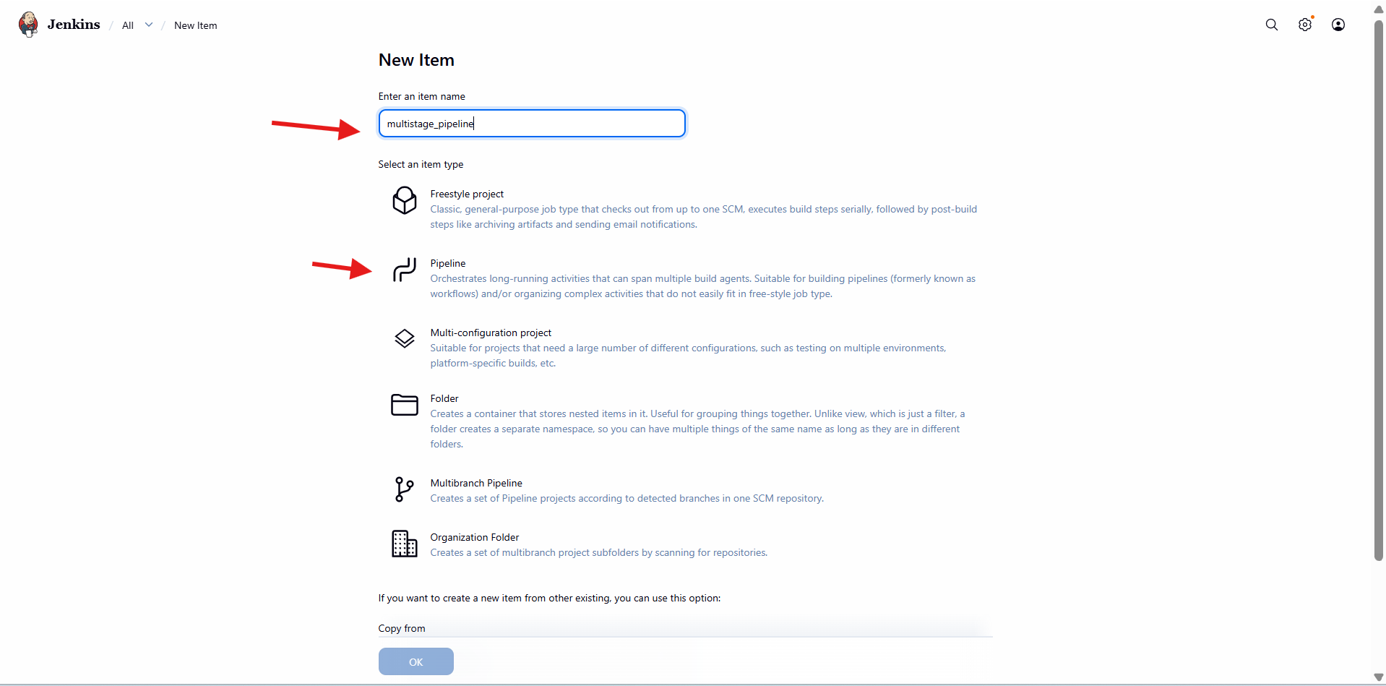

- Opened Configure → Pipeline
- Used Declarative pipeline
- Defined:
  - agent any
  - timestamps()
- Configured environment variables:
  - Maven home and PATH
  - Sonar project key and name
  - Nexus URL, repository, protocol
  - Group ID, artifact ID, version
  - Tomcat URL
  - Slack channel

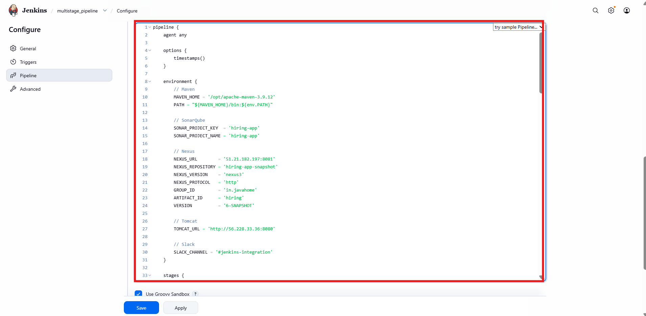

- Added Initialize stage
- Added Notify Build Started stage (Slack)
- Added Checkout Source Code stage
  - GitHub repository
  - Branch: main
- Added Code Quality Analysis stage
  - Integrated SonarQube
  - Executed Maven Sonar scan
- Added Build Application stage
  - mvn clean package -DskipTests
  - WAR generated under target/

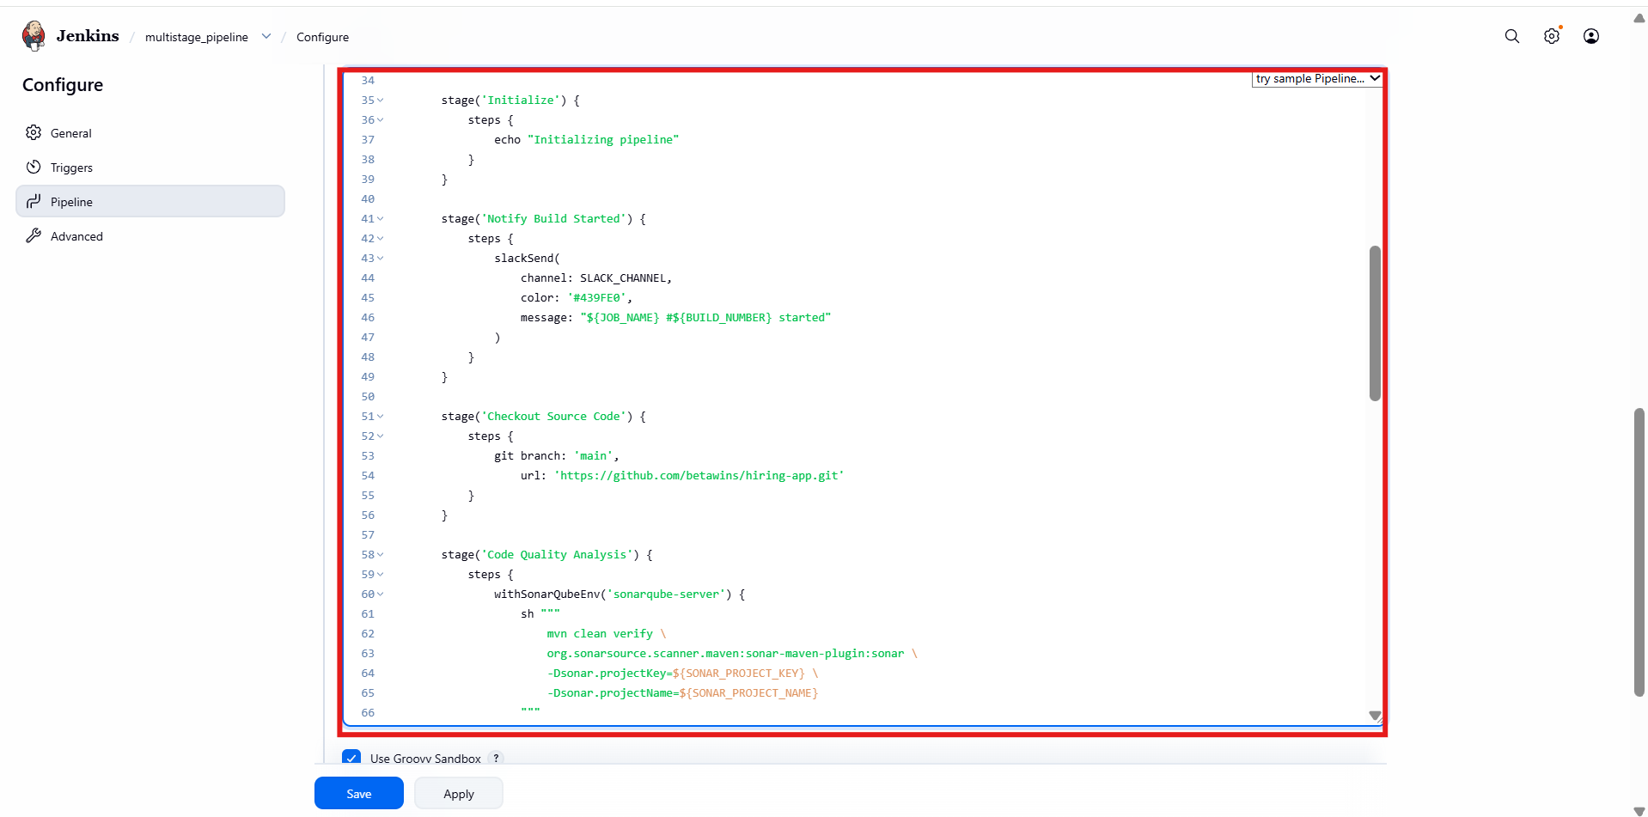

- Added Publish Artifact to Nexus stage
  - Used Sonatype Nexus Repository
  - Snapshot repository
  - WAR file upload
- Added Deploy to Tomcat stage
  - Tomcat credentials
  - Tomcat URL
  - Context path: hiring
  - WAR: target/hiring.war

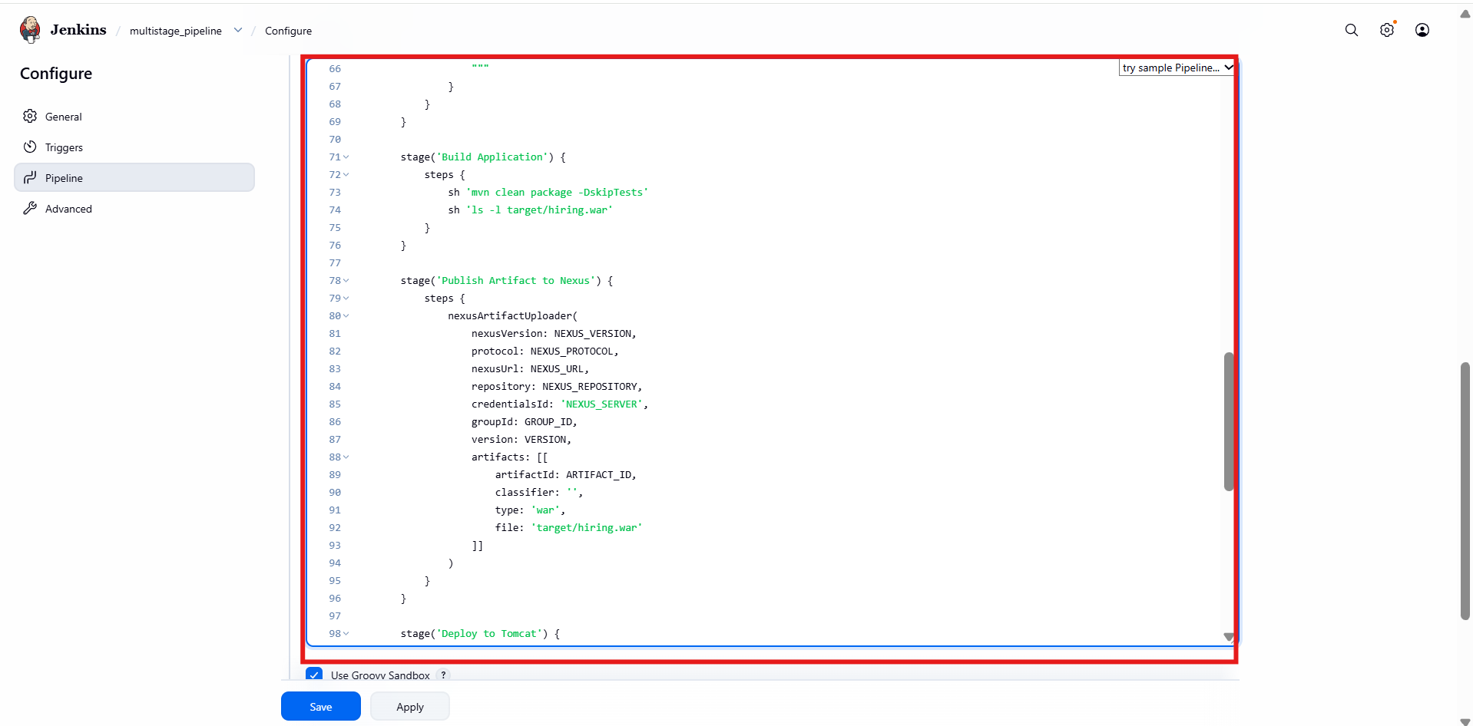

- Added post section
- On success:
  - Slack success notification
- On failure:
  - Slack failure notification

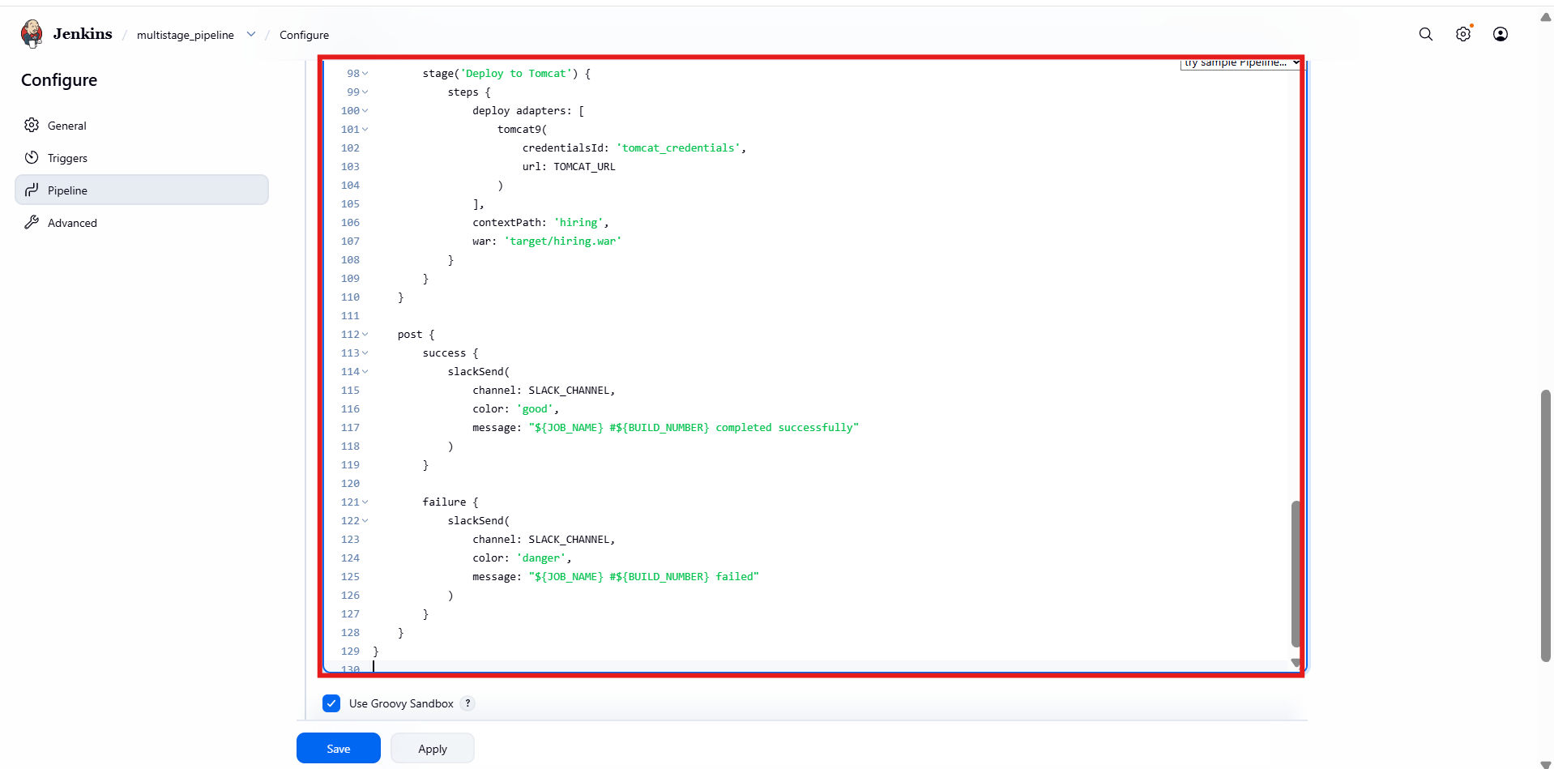
- Pipeline executed successfully
- Stages completed in order:
  - Initialize
  - Notify Build Started
  - Checkout Source Code
  - Code Quality Analysis
  - Build Application
  - Publish Artifact to Nexus
  - Deploy to Tomcat
  - Post Actions
- All stages shown in green

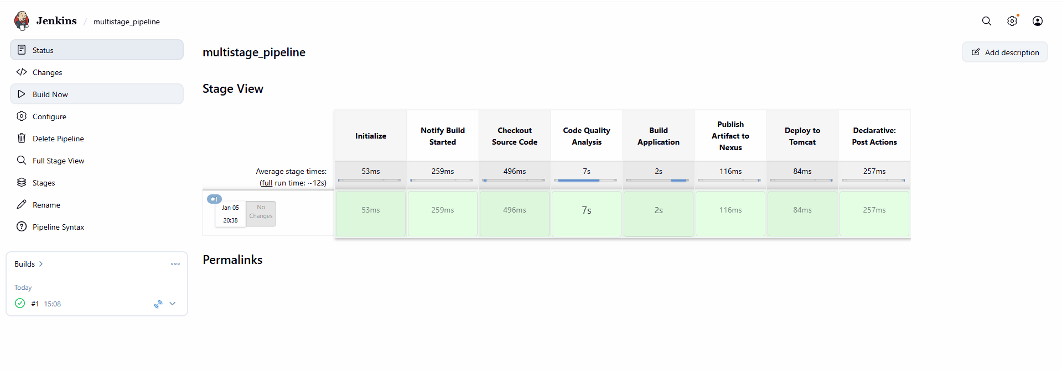

- Create one parallel stage pipeline job

- Open Jenkins dashboard
- Click New Item
- Enter job name: parallel_stage
- Select Pipeline
- Click OK

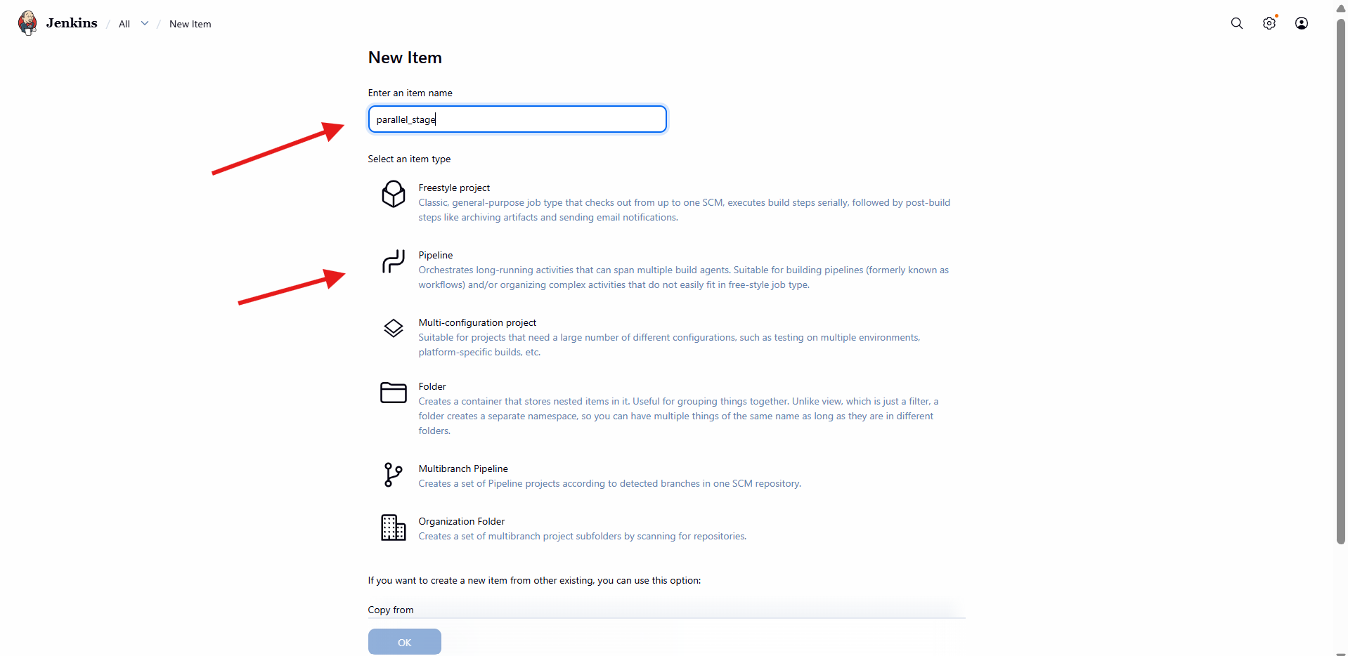
Go to Configure → Pipeline
Set Definition to Pipeline script
Paste the pipeline script that contains:
- pipeline { agent any }
- environment {} block for Maven, SonarQube, Nexus, Tomcat, Slack
- Multiple stage {} blocks
- One stage using parallel { }

Maven home path configured
SonarQube project key and name defined
Nexus URL, repository, version, protocol defined
Tomcat URL defined
Slack channel defined
Timestamps enabled in options

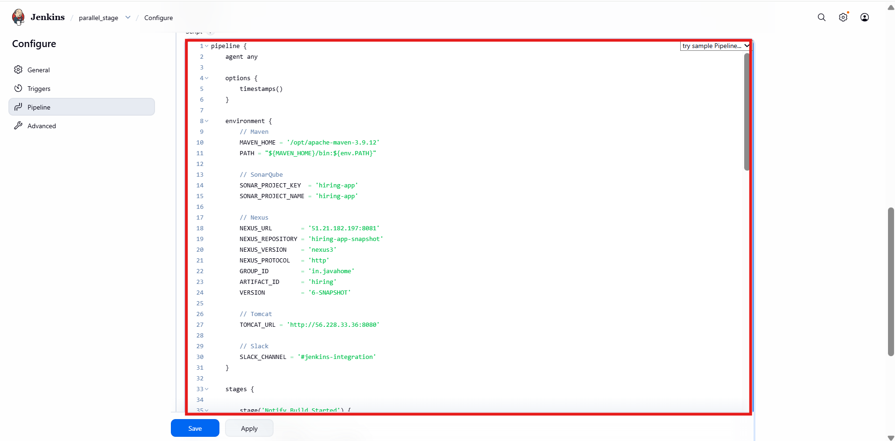

- Stage name: Initialize
- Prints initialization message using echo
- Stage name: Checkout Source Code
- Git repository URL configured
- Branch set to main

Stage name: Parallel Tasks
Inside this stage, parallel {} block used
SonarQube analysis runs as one parallel task
Maven build runs in parallel
- Uses withSonarQubeEnv
- Runs Maven verify
- Executes Sonar scanner with project key and name
- Quality gate result shown as Passed

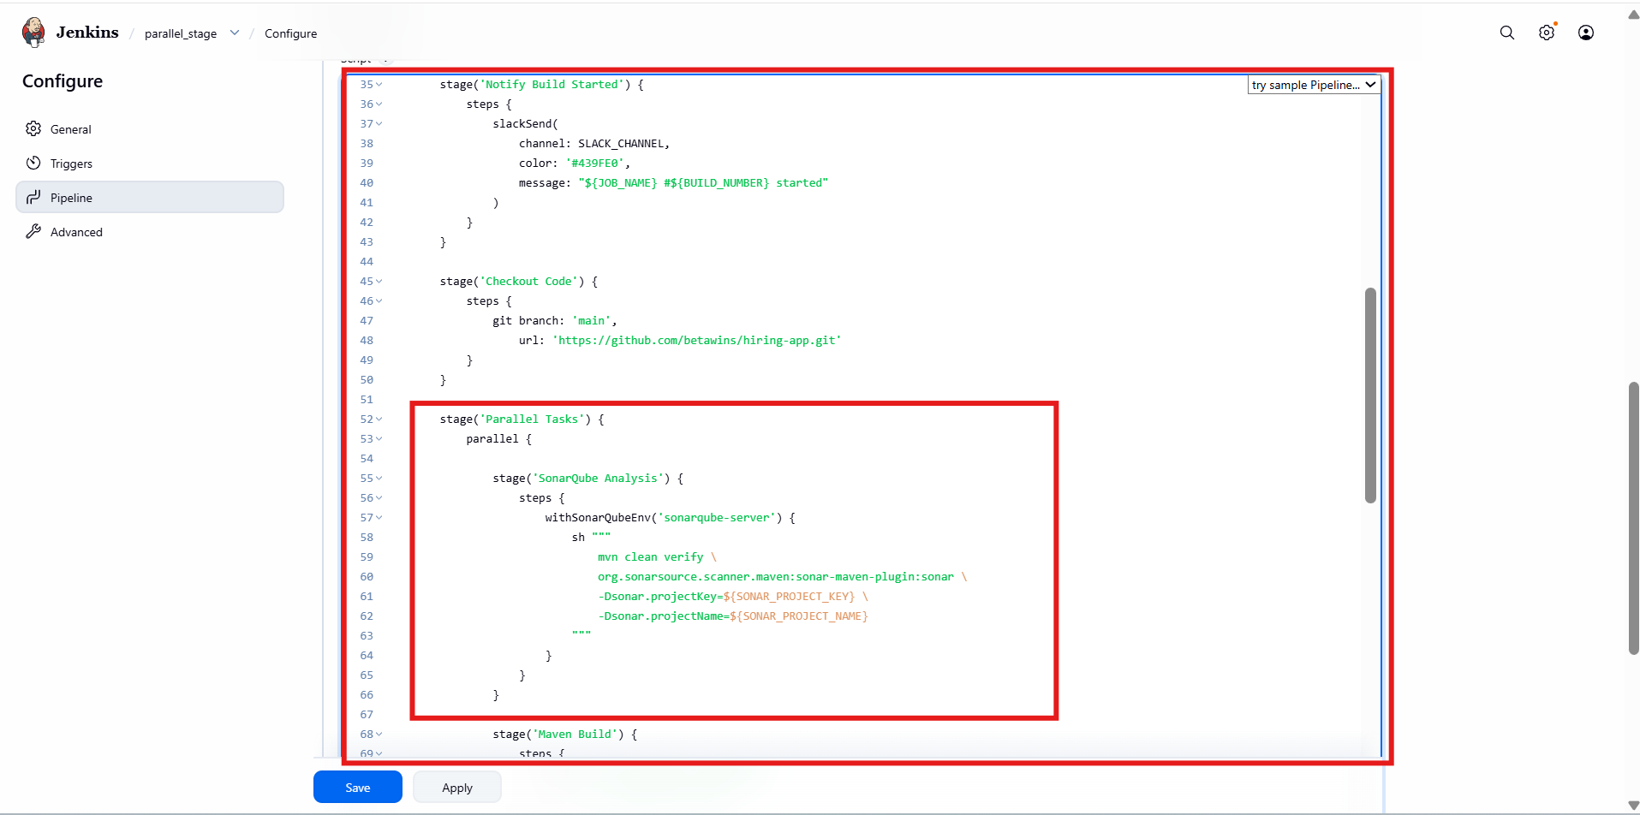

- Runs Maven clean package
- Skips tests using -DskipTests
- WAR file generated in target/

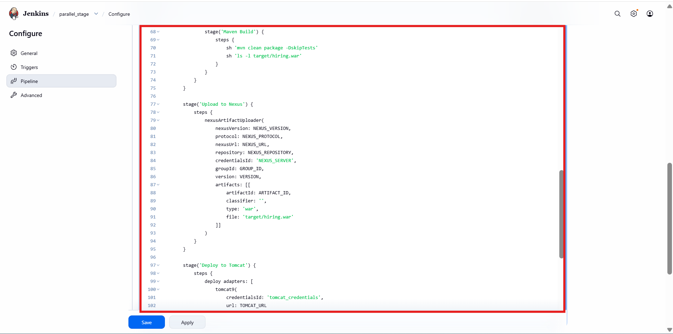
Stage name: Deploy to Tomcat
Uses Tomcat deployment adapter
Credentials configured
Context path set
WAR deployed successfully
On success
- Slack success notification sent
On failure
- Slack failure notification sent

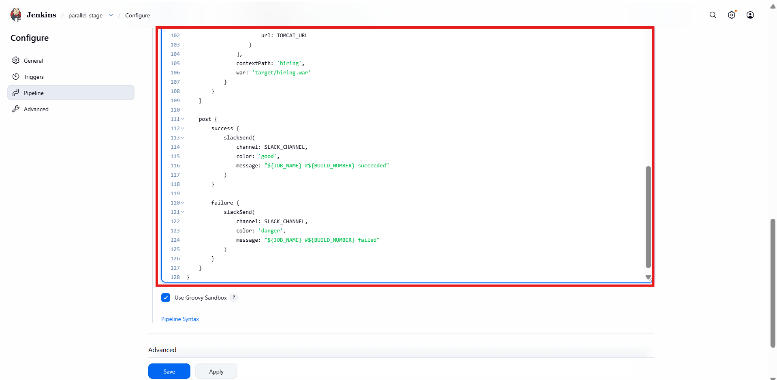
- Click Build Now
- Stage View shows:
  - Parallel execution happening
  - Green blocks for success
- Total build time reduced due to parallel execution
- Pipeline completed successfully
- Parallel stage executed correctly
- Artifact uploaded to Nexus
- Application deployed to Tomcat
- Slack notifications triggered

